mtu

Murex Welding Products Limited, Hertford Road, Waltham C ross , Hertfordshire EN8 7RP Website : www .murexwelding .co .uk

The Murex Transarc "Open Circuit Voltage Reducer" is designed for use when Manual Metal Arc welding up to 400A with either a DC (rectifier or generator) or AC (transformer) power sources. It provides a low voltage at the electrode holder (<24Vdc) when welding is not in progress. This reduces the risk of electric shock when operating in areas of increased hazard.

In-Line MMA Open Circuit Voltage Reducer Meets all new ENs and safety legislation
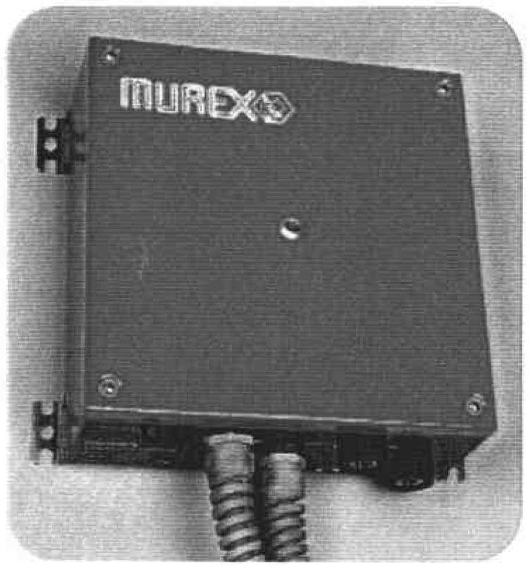

t AC or DC operation

Safe 24V de at the electrode when arc not struck No auxiliary power required to operate
Sealed wall mountable metal enclosure

Specification

.lb.;

Unique stall protection circuit switches off power if electrode frozen in weld

Voltage reduced to 24V within 0.3 seconds of breaking the arc

Power Source OVC: Polarity:
Rating:

1OOV RMS or Average t-1\0..X.
AC or DC
400A at 35% duty (10 min)
300A at 60%
250A 100%

Reset Times: Standards: Dimensions: Weight (net):

T1:0-2sec, T2: 0.3-2secs EN609741, EN50199, IP23
300x300x120mm
11.5kg

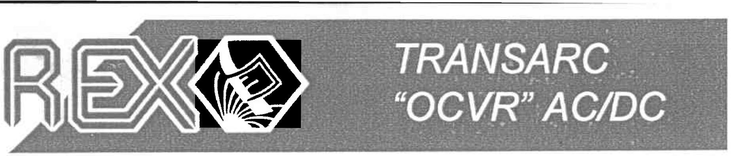
Reduced OCV:
Arc snaps
Electrode momentarily out
touched to work Electrode t
pulled away
Electrode from work
touched to t
Ele<:trode work gain, Normal Normal
Movement strik ing the arc Welding Welding
+

r--- - --;·...... .................. ... ....... yln;

Tl
I ·---
-- -- ·-·_.. -·-_·_- _._.. .. r-- -- -_- _··_·_···__··_···--·
l l
If arc: not struck OCV reduced to
within time T1 24Vdc after lime T2
OCV reduced lo 24Vdc:
T1 variable 0 to 2 sees
T2 va · ble 0• | .3 to 2 sees

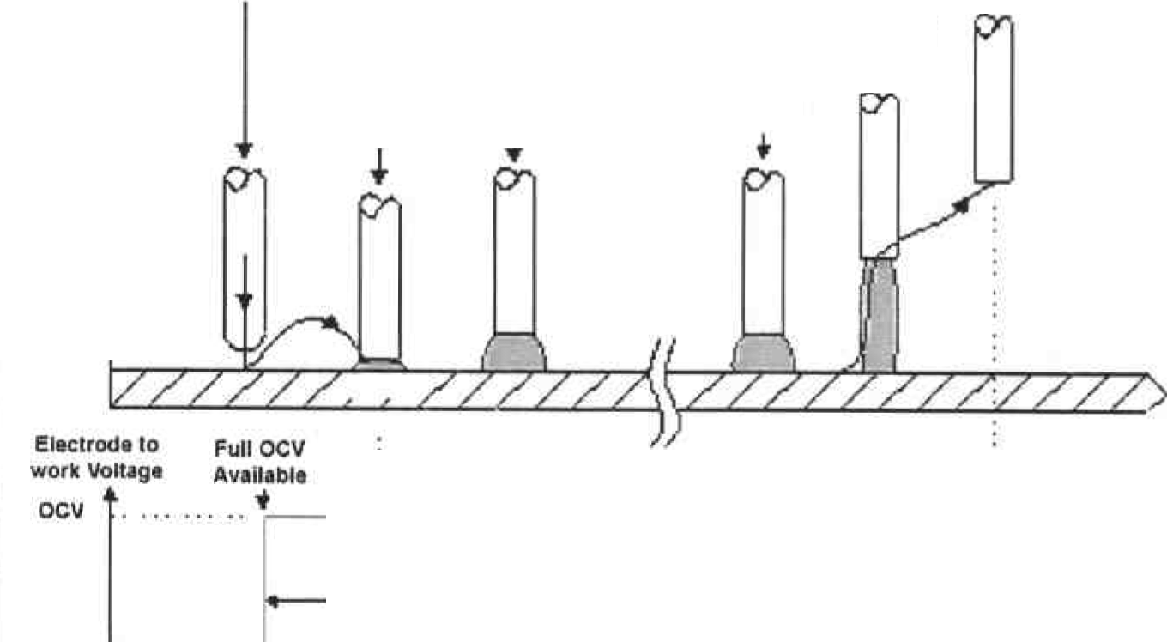
Operation
24Vdc max
Part No: 1415590




Transarc OCVR AC/DC
Open _.Circuit Voltage Redu·cer

Introduction

The Murex Transarc "Open Circuit Voltage Reducer" is designed for use when Manual Metal Arc welding up to 400A with either DC (rectifier) or AC (transformer) power sources . It provides a low voltage at the electrode holder (<24Vdc) when welding is not in progress. This reduces the risk of electric shock when operating in areas of increased hazard.

Manufactured in a fully enclosed weatherproof case the unit should be vertically mounted on a suitable wall or bulkhead (cables and connections under). No auxiliary or independent power is required to run the unit as it is powered automatically from the open circuit or arc voltage. A red indicator light on the cover panel is illuminated when reduced OCV is present at the electrode holder .

An exclusive monitoring circuit in the Transarc OCVR senses if the electrode is stalled or stuck on the work and automatically disconnects welding output.

Specification

Power Source OVC: Polarity :
Rating:

Reduced OCV:

1OOV RMS or Average AC or DC
400A at 35% duty (10 min)
300A at 60%
250A at 100%
24Vdc max

Reset Times: Standards: Dimensions: Weight (net) :
T1: 0-2sec, T2: 0.3-2secs EN609741, EN50199 , IP23
300x300x120mm 11.5kg

Installation/Connection

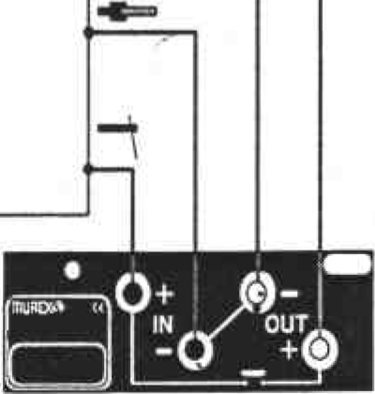
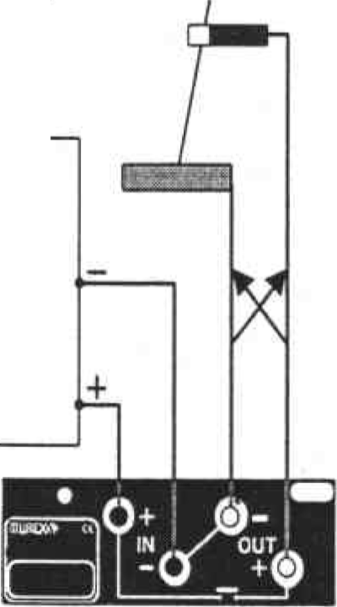
It is recommended that the unit be vertically mounted on a convenient wall or bulkhead with the inlets and outlets at the bottom to prevent the ingress of water. Although the unit is weatherproof, Murex recommends that it is protected from rain or direct water spray . DO NOT WELD IN THE RAIN

DC Pos or Neg AC
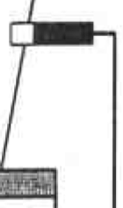

DC
Rectifier
or Generator

AC
Transformer

IN DC DO NOT REVERSE THE POWER SOURCE CONNECTIONS



